**CPE223 – Signals and Systems**



**Lab # 1**

**To Identify the Continuous and Discrete Time Signals Using MATLAB.**

|  |  |
| --- | --- |
| **Name** | Muhammad Aizaz Arshad. |
| **Registration Number** | 088. |
| **Class** | FA18-BCE-A. |
| **Instructor’s Name** | Sir Umair Shafique Khan. |

**Assessment**

|  |  |  |  |
| --- | --- | --- | --- |
| **Performance** |  |  | **Total** |
| **Results** |  |  |
| **Lab Report** |  |
| **Viva** |  |

**OBJECTIVES:**

Describe the basic operations and commands in MATLAB and also describe the steps involved in plotting the Continuous and Discrete time signals in MATLAB.

**REQUIRED EQUIPMENT:**

Software:

• MATLAB

**METHODOLOGY:**

This lab was designed to perform basic tasks such as plotting the simple discrete and continuous time signals in the MATLAB software using figure and plot commands. Another thing performed here in this lab was further editing of the figures to achieve desirable appearance of the plots. For example, setting the graph title, y limits, legend for the curve etc. There are two types of files generated in MATLAB first is script file and the second one is function file. Suppose that we want to plot a function y(x), where x is the independent variable. The procedure to plot y(x) is as follows: First the vector x is created, such as a x b, where a, b are scalars. The function y(x) will be plotted over the interval [a, b]. Next, we create the vector y, which is of the same length as x; that is, the two vectors have an equal number of elements. It is possible to plot more than one function in the same ﬁgure by employing a different syntax of the command plot

Up to this point, all plots were made in a single ﬁgure. By typing at the command prompt figure, a new ﬁgure with name appears without closing the old ﬁgure.

A discrete time function is a function of the form. In this case the appropriate command for plotting the function is ‘stem (n,f)’

Functions are also M-Files, that is, are ﬁles with extension .m and must be saved in the current directory of MATLAB.

**LAB TASK:**

t=-5:0.1:5;

f=t.*cos(2*pi*t); plot(t,f)

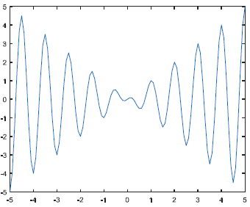

Task 2:

x=-2:2 % independent variable

length (x)

y=x.^2 % Function

length (y)

plot(x,y)

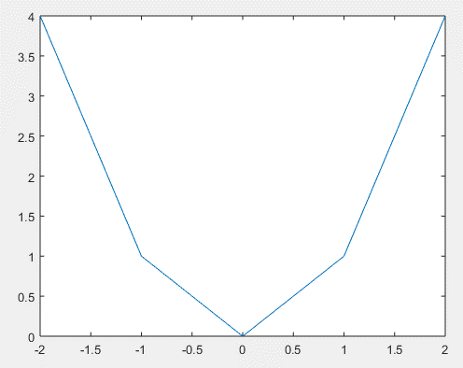

Task 3:

x = linspace(0,2*pi,100) % linspace could be used to create a vector.

x=0:pi/50:2*pi % this is same value as above. Both method are correct

y = (x.^2).*cos(x);

g = x.*cos(x);

f = (2.^x).*sin(x);

plot(x,y,x,g,x,f)

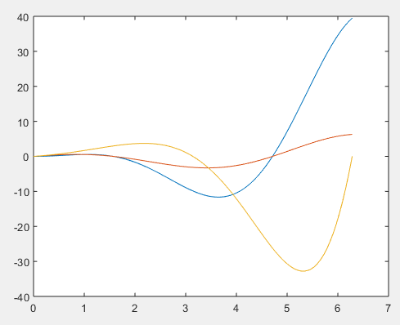

Task 4:

x = linspace(0,2*pi,150);

plot(x,cos(x),'r*',x,sin(x),'k')

xlabel('Time Axis')

ylabel('Amplitude')

title('Graph of cos(x) & sin(x)')

legend('cos','sine')

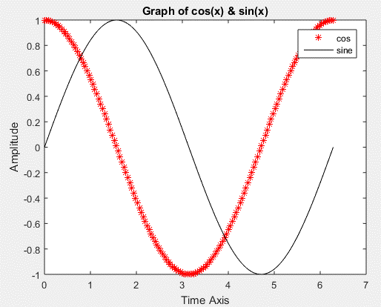

Task 5:

n = -3:3

f= n.^2

stem(n,f)

xlabel('Time Axis')

ylabel('Amplitude')

title('Graph of f(n)')

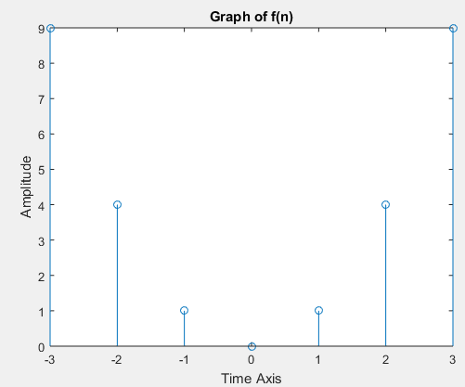

Task 6:

t1=-2:.1:2;

t2=2.1:.1:4.9;

t3=5:.1:8;

f1=ones(size(t1));

f2=zeros(size(t2));

f3=t3.*sin(4*pi*t3);

t=[t1 t2 t3];

f=[f1 f2 f3];

plot(t,f)

title('Multi-part function f(t)')

xlabel( 'time')

ylabel( 'Amplitude')

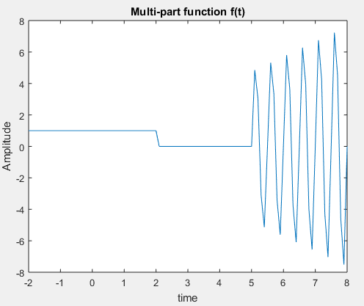

**CONCLUSION:**

In this lab we have learned basic commands in MATLAB and plot different signals in it. We verify the given codes in the lab and modify them to get better results. As, we also plot continuous and discrete time function to verify its plotting commands and signal. Plotting of different signals was analyzed in this lab. Different signals were visualized describing basic operations and commands.